|  |  |  |  |  |
| --- | --- | --- | --- | --- |
| **C:\Users\neşe\Desktop\header-meb-yeni-logo.png** | **{OGRETIM_YILI} EĞİTİM ÖĞRETİM YILI**  **{OKUL_ADI}**  **8. SINIF İNGİLİZCE DERSİ 2. DÖNEM 1. YAZILI SORULARI** | | | **C:\Users\neşe\Desktop\header-meb-yeni-logo.png** |
| **Adı:**  **Soyadı:** | **Sınıfı: 8/…**  **No:** | **Aldığı Not:** |

**1. Match the words with the pictures. (8*3=24)**

***Rock climbing – caving – skiing –paragliding- hiking– mountain biking- motor racing- parkour running***

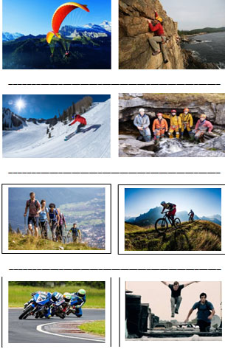

**2. Read the text and write True and False. (7*3=21)**

|  |
| --- |
|  |

John :There are lots of things to do in Cairo. I think you should start with visiting the citadel and exploring the Pyramids of Giza. Then, you should go shopping at Khan Al-Khalili, go for a walk in Zamalek, and spend time in Islamic Cairo.

Mike: Sydney is an excellent place to have an enjoyable holiday, because you spend a lot of time on the beach. You can go on a boat trip, sail under the Harbour Bridge, visit the Opera House and see a lot of kangaroos.

Doris: Antalya is a marvellous place to see the sun, sand and history together. You can see Aspendos Theatre there and stay at a five-star all-inclusive hotel by the sea. It is really relaxing and fun.

1. Mike prefers going shopping. __

2. Mike prefers spending time on the beach. __

3. John has visited the citadel in Cairo. __

4. John has stayed at an all-inclusive hotel. __

5. Doris had a relaxing holiday. __

6. Doris visited the Opera House __

7. Doris explored the Pyramids of Giza. __

8. Mike experienced water sports. __

**3. Fill in the blanks with “prefer” “would rather”. (5*2=10)**

1. I ____________ travelling by bus to travelling by train.

2. John ____________ walking to running.

3. They ____________ visit historic sites than modern cities.

4. Jack ____________ watch TV than going out.

5. She ____________ going to the cinema to sitting at home.

**4. Fill in the blanks with the comparative form of the Adjectives (5*2=10)**

1. İstanbul is ____________ İzmir. ( crowded ),

2. Mr. Smith is ____________ Mr. Taylor. ( smart )

3. Hang gliding is ____________ caving. ( challenging)

4. Everest mount is ____________ Nemrutmount.( high )

5. The Sahara is ____________ The Gobi. ( large )

**5. MATCH THE WORDS WITH THEIR MEANINGS. (10*1=10)**

1. ancient                         6. province

2. architecture     7. village

3. capital               8. handcrafts

4. destination      9. trade route

5. gift                     10. meatball

(....) köy                 (....) el sanatları

(....) başkent         (....) gidilecekyer

(....) köfte              (....) antik

(....) hediye           (....) mimari

(....) il                     (....) ticaretyolu

**6. MATCH THE WORDS WITH THE PICTURES. (5*2=10)**

***1. HELMET 2. PADDLES 3. GLOVES 4. DROWN 5. COAL MINERS***

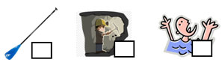

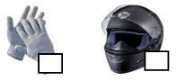

**7. MATCH THE WORDS WITH THE PHRASES? (15*1:15)**

***\*Vacuum *wash *mow *load *set/ lay *sweep *clean *take *wash *mop *do *Take *do *take out *hang out***

_______ the laundry

_______ the car

_______ the lawn

_______ the dishwasher

_______ the table

_______ the dog for a walk

_______ the care of the cat

_______ the house

_______ the dishes

_______ the floor

_______ the grocery shopping

_______ the garbage

_______ the bathroom

_______ the leaves

_______ the clothes

**BAŞARILAR DİLERİM...**

**{OGRETMEN_ADI}**

[**https://www.soruindir.net**](https://www.soruindir.net)